AMAZON S3 IMPLEMENTATION REPORT
Bucket Creation, Configuration & Document Upload
Bucket: ak-092 | Region: US East (N. Virginia) – us-east-1

Service | Amazon Simple Storage Service (Amazon S3)
Bucket | ak-092
Region | US East (N. Virginia) – us-east-1
Final upload | 1 DOCX file, 549.7 KB, upload succeeded

1. Executive Summary
- The screenshots document a complete Amazon S3 bucket setup and object-upload workflow.
- A General purpose S3 bucket named “ak-092” was created in the US East (N. Virginia) region (us-east-1).
- The configuration shown keeps Block all public access enabled, leaves Bucket Versioning disabled, and uses server-side encryption with Amazon S3 managed keys (SSE-S3).
- After bucket creation, an AWS EC2/EBS Infrastructure Report in DOCX format was uploaded successfully. The final upload status shows one successful file totaling 549.7 KB and no failures.
- The final object-properties screen provides the stored object's S3 URI, ARN, size, type, ETag, region, and object URL.

2. Configuration Summary
Setting | Observed configuration | Summary
Bucket type | General purpose | Standard S3 bucket configuration for common workloads.
Region | US East (N. Virginia) / us-east-1 | The screenshots consistently show this AWS region.
Bucket name | ak-092 | Bucket was successfully created with this name.
Namespace | Global namespace | The Global namespace option is selected in the creation workflow.
Object ownership | Bucket owner enforced | The creation form displays bucket-owner-enforced ownership.
Public access | Block all public access: enabled | All four visible public-access blocking controls are checked.
Versioning | Disabled | Versioning is not enabled in the shown configuration.
Encryption | SSE-S3 | Amazon S3 managed keys are selected for server-side encryption.
S3 Bucket Key | Enabled | The displayed encryption settings show Bucket Key enabled.
Tags | None | The optional Tags section shows no associated tags.

3. Implementation Steps and Summaries
Step | Activity | Summary
1 | Open Amazon S3 | The AWS console is opened on the Amazon S3 landing page. The console is set to US East (N. Virginia).
2 | Start bucket creation | The Create bucket workflow is launched and General purpose is selected.
3 | Configure bucket identity | The bucket is configured in us-east-1 and named “ak-092”.
4 | Configure access protection | Block all public access remains enabled, including the four underlying public-access controls.
5 | Configure versioning | Bucket Versioning is left Disabled.
6 | Configure encryption | Default encryption uses SSE-S3 with Amazon S3 managed keys; S3 Bucket Key is enabled.
7 | Create bucket | The console confirms successful creation of “ak-092”.
8 | Upload document | The AWS EC2/EBS Infrastructure Report DOCX is selected and uploaded to the bucket.
9 | Verify upload | The upload status confirms 1 successful file (549.7 KB) and 0 failed files.
10 | Verify object properties | The stored object's S3 URI, ARN, region, size, type, ETag and object URL are visible.

4. Result and Verification
Bucket creation: Successful. The S3 console explicitly displays a green confirmation that bucket “ak-092” was created.
Object upload: Successful. The upload-status screen reports 1 file succeeded (549.7 KB; 100%) and 0 files failed.
Stored object: AWS_EC2_EBS_Infrastructure_Report (1).docx is visible in the bucket and its properties are accessible.

5. Key Observations
- The bucket is configured as a General purpose S3 bucket.
- The screenshots show public access protection enabled through Block all public access.
- Object versioning is disabled, so the shown configuration does not retain multiple S3 object versions.
- Default server-side encryption is enabled using SSE-S3, with S3 Bucket Key enabled.
- The workflow successfully demonstrates both bucket provisioning and object storage.
- The final object-properties page provides the information needed to verify that the document is stored in the intended bucket and AWS region.

6. Screenshot Evidence
The following screenshots are included as evidence of the configuration and workflow. Each image is accompanied by a concise summary of what it demonstrates.

6.1 Amazon S3 landing page
The Amazon S3 console is opened in the US East (N. Virginia) region. The page introduces S3 as an object storage service for storing and retrieving data.
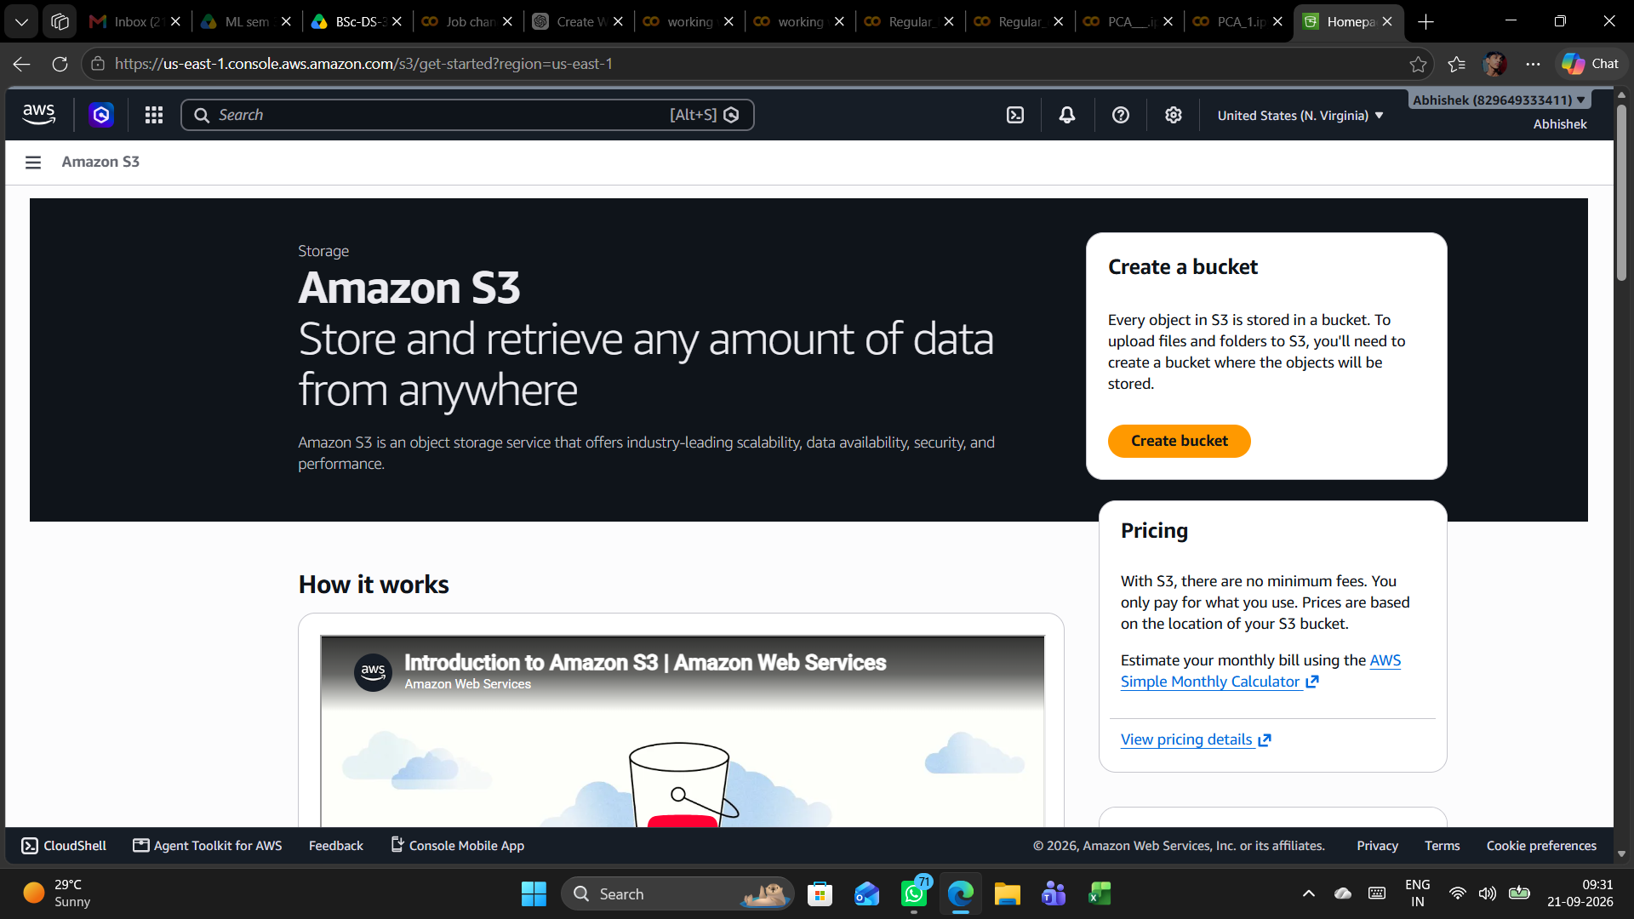

6.2 Create bucket – initial configuration
The Create bucket workflow is opened. The selected bucket type is General purpose, which is intended for common S3 storage use cases.
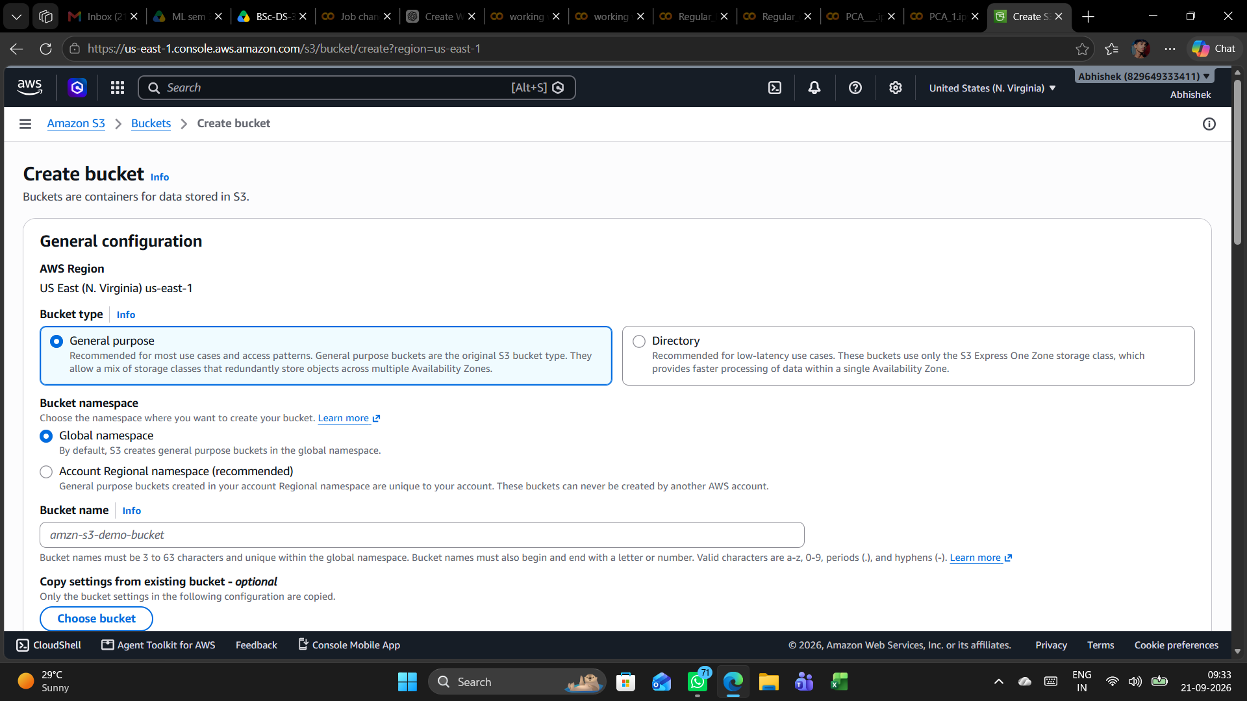

6.3 Bucket configuration and naming
The bucket is configured in US East (N. Virginia), us-east-1. General purpose and Global namespace are selected, and the bucket name field is prepared for the required name.
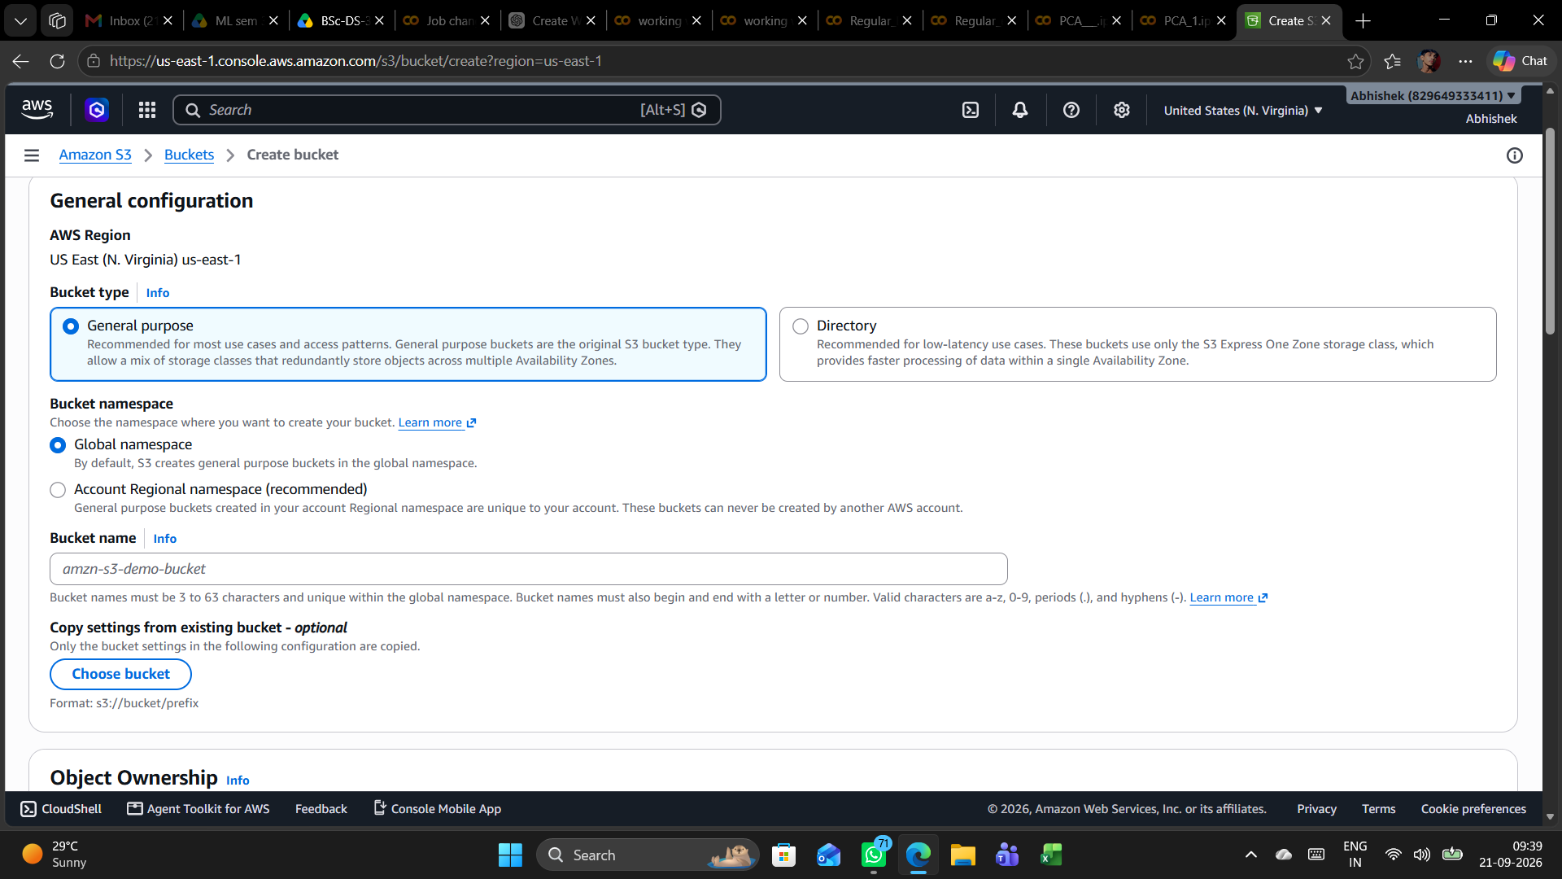

6.4 Bucket name entered
The bucket name is entered as “ak-092”. The name satisfies the visible S3 naming format requirements shown in the console.
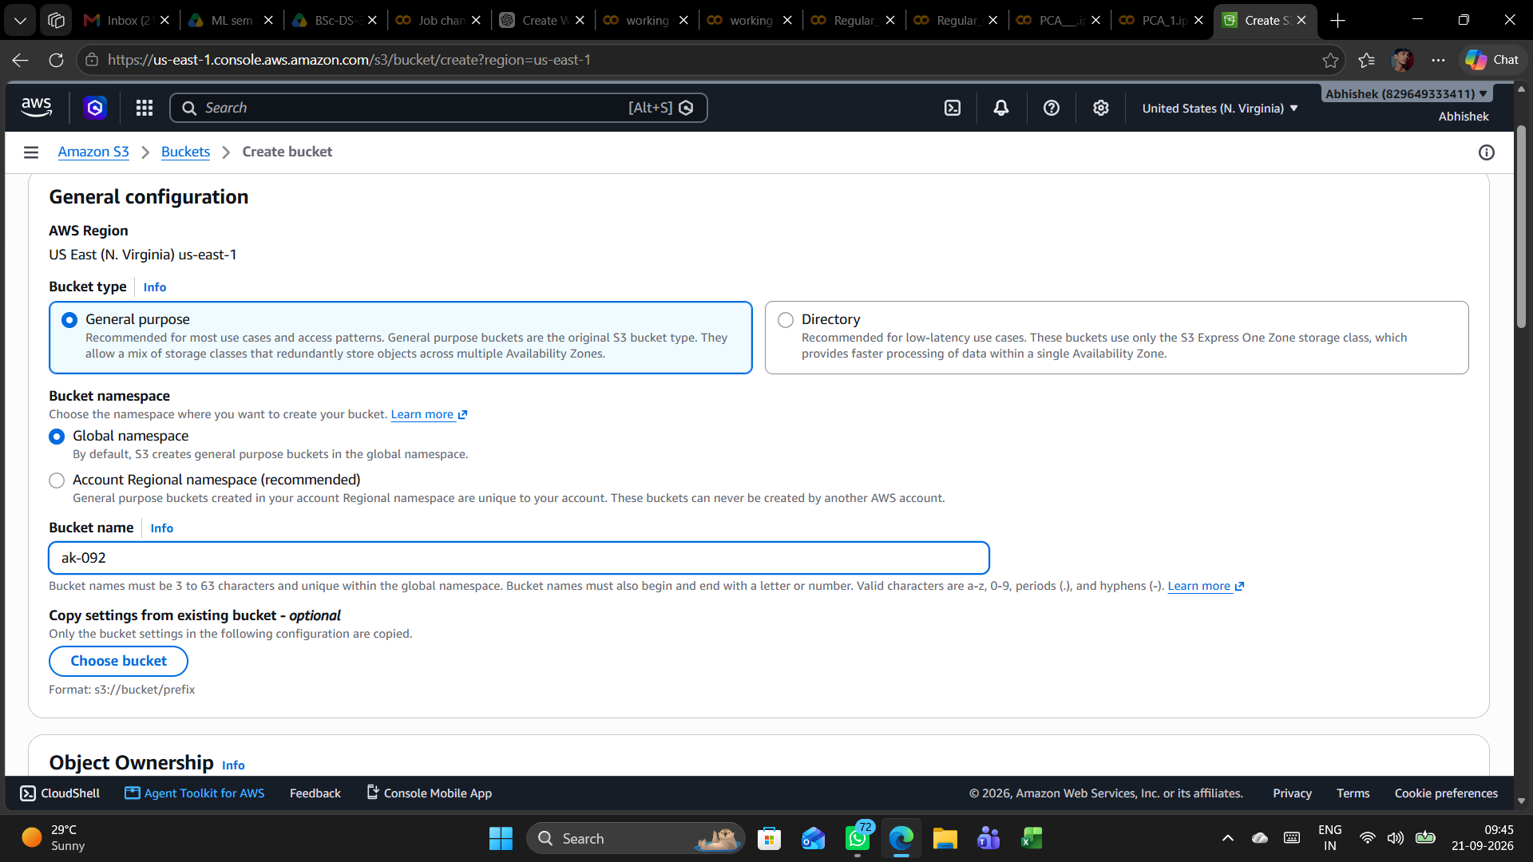

6.5 Versioning and tagging settings
Bucket Versioning is shown as Disabled. The optional Tags section is left without tags.
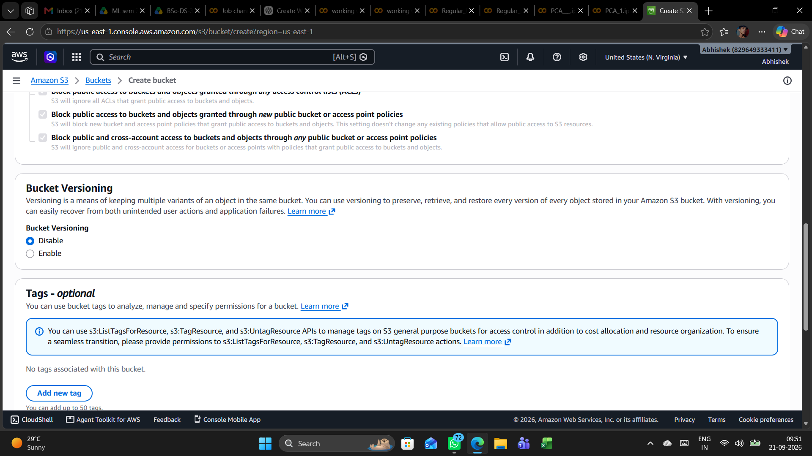

6.6 Default encryption
Default server-side encryption is configured with Amazon S3 managed keys (SSE-S3). S3 Bucket Key is enabled in the displayed configuration.
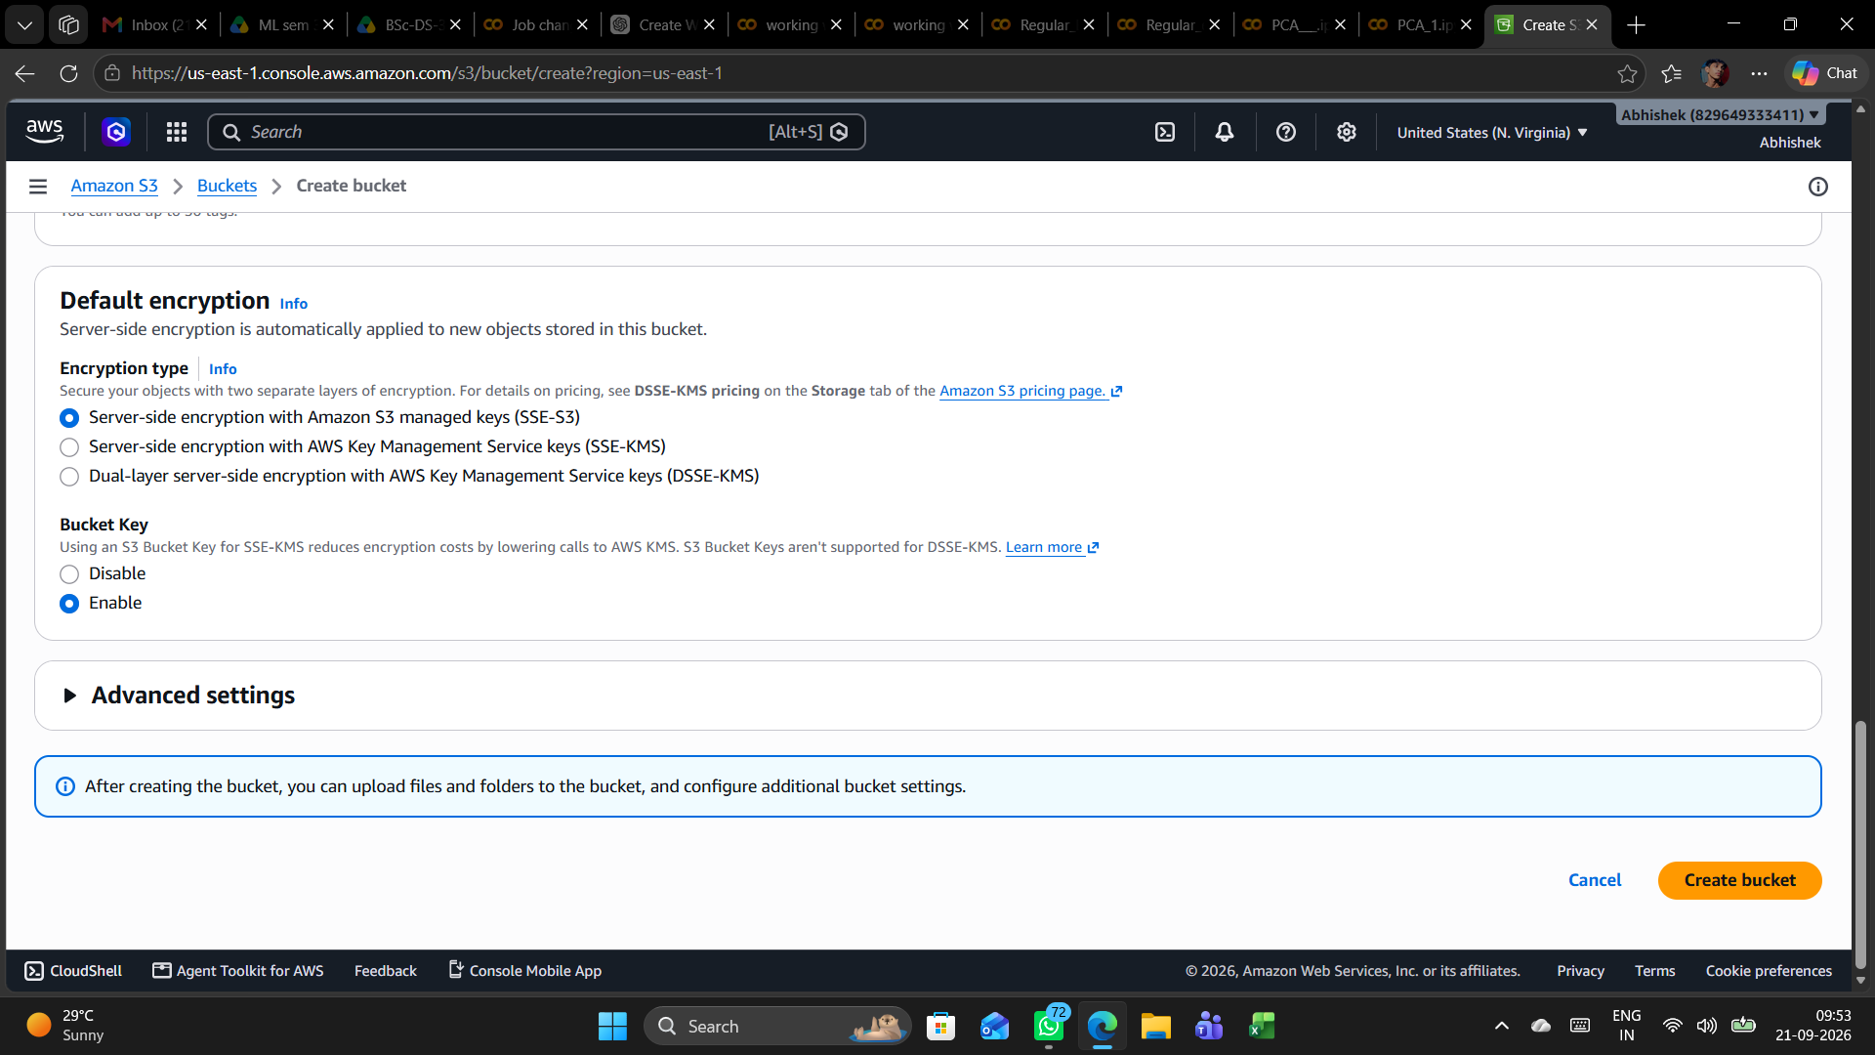

6.7 Encryption and advanced settings
The lower portion of the bucket creation form confirms the encryption configuration and shows that additional advanced settings can be configured if required.
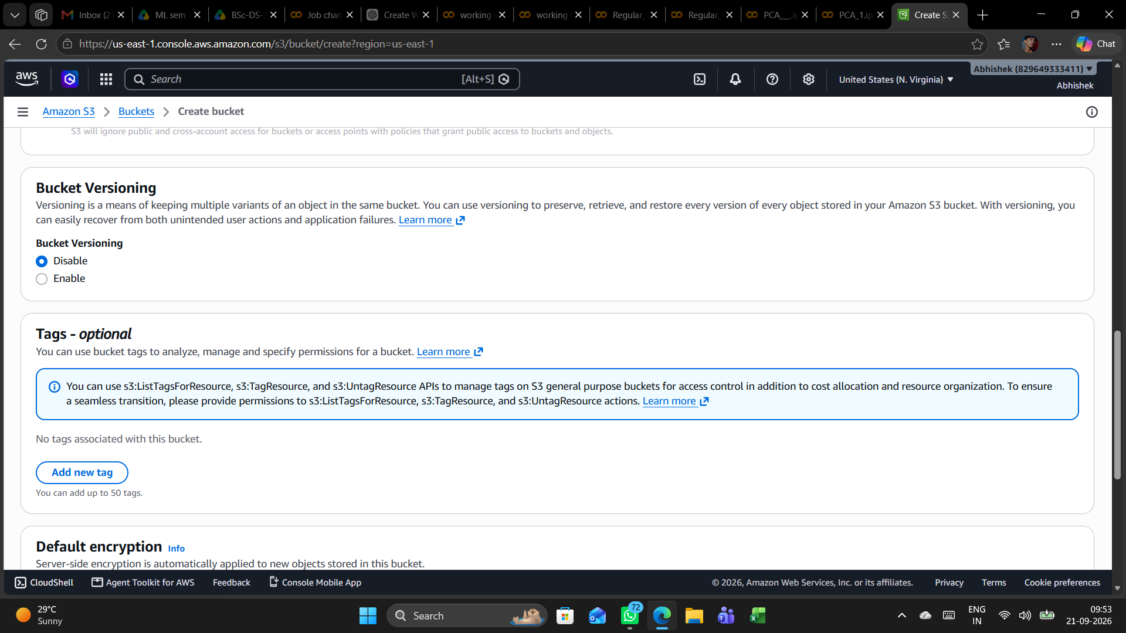

6.8 Public access and versioning
Block all public access is enabled. The four underlying public-access blocking controls are checked, while Bucket Versioning remains Disabled.
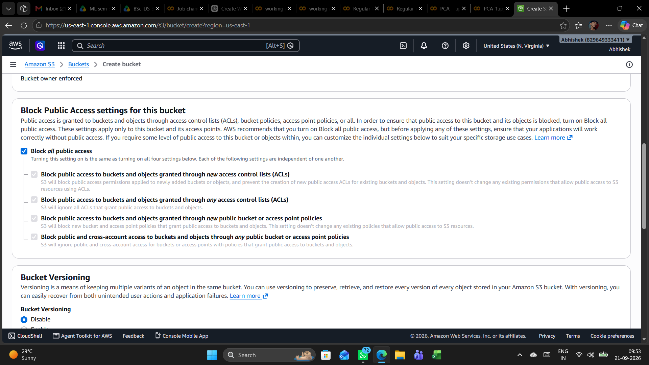

6.9 Bucket created successfully
The console confirms successful creation of the S3 bucket “ak-092”. The bucket initially contains zero objects.
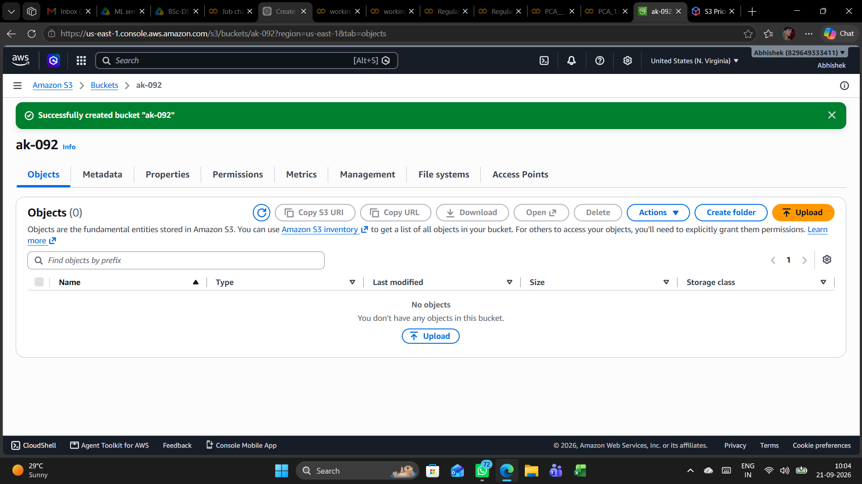

6.10 Empty bucket view
The Objects tab for “ak-092” is displayed and confirms that no objects are present before the upload operation.
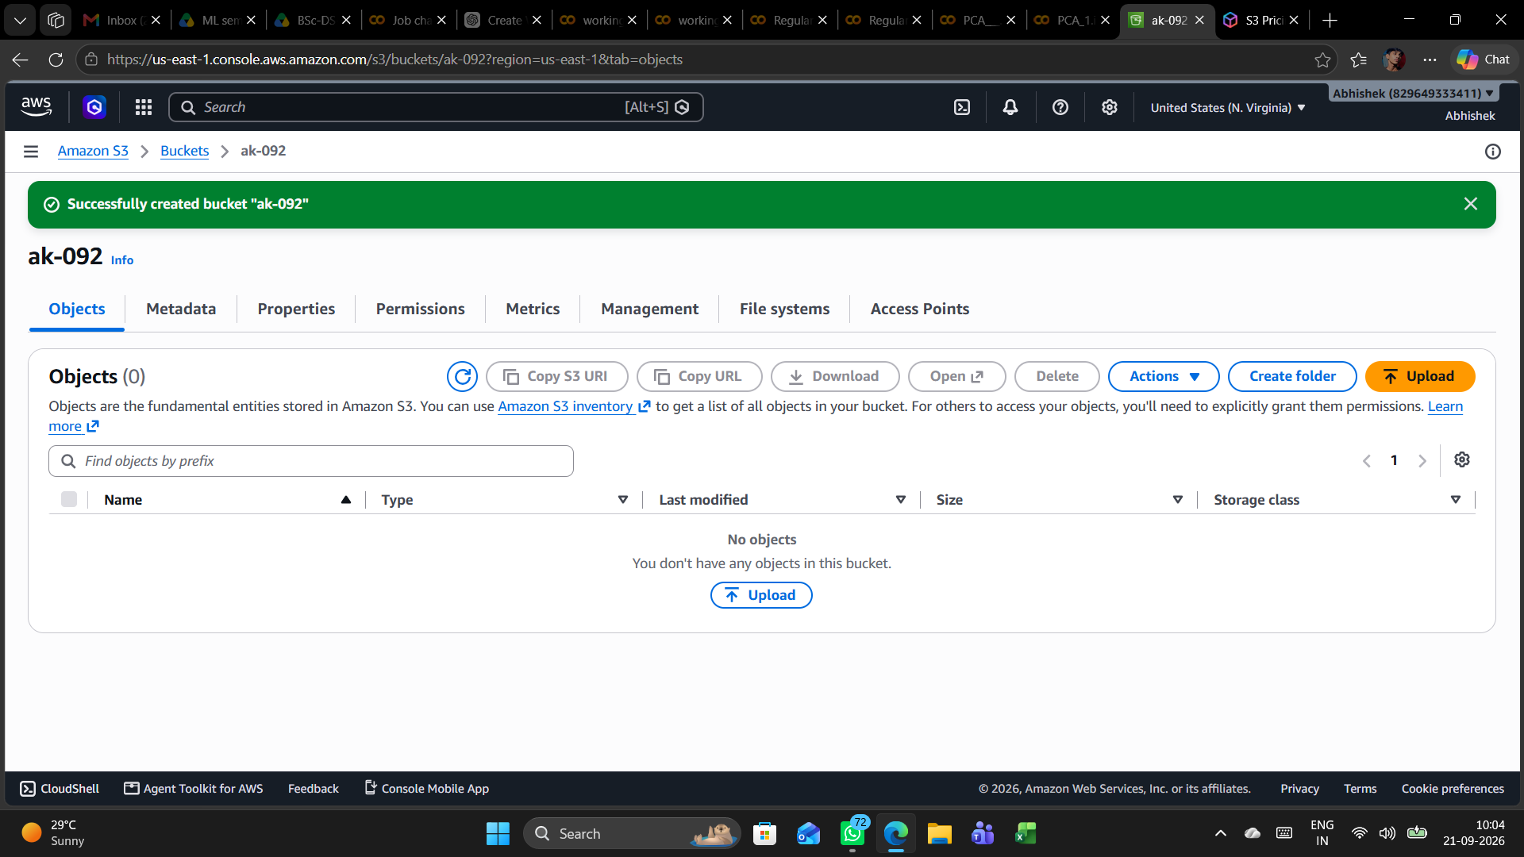

6.11 Upload document to S3
An AWS EC2/EBS Infrastructure Report DOCX file is selected for upload. The destination is the “ak-092” S3 bucket.
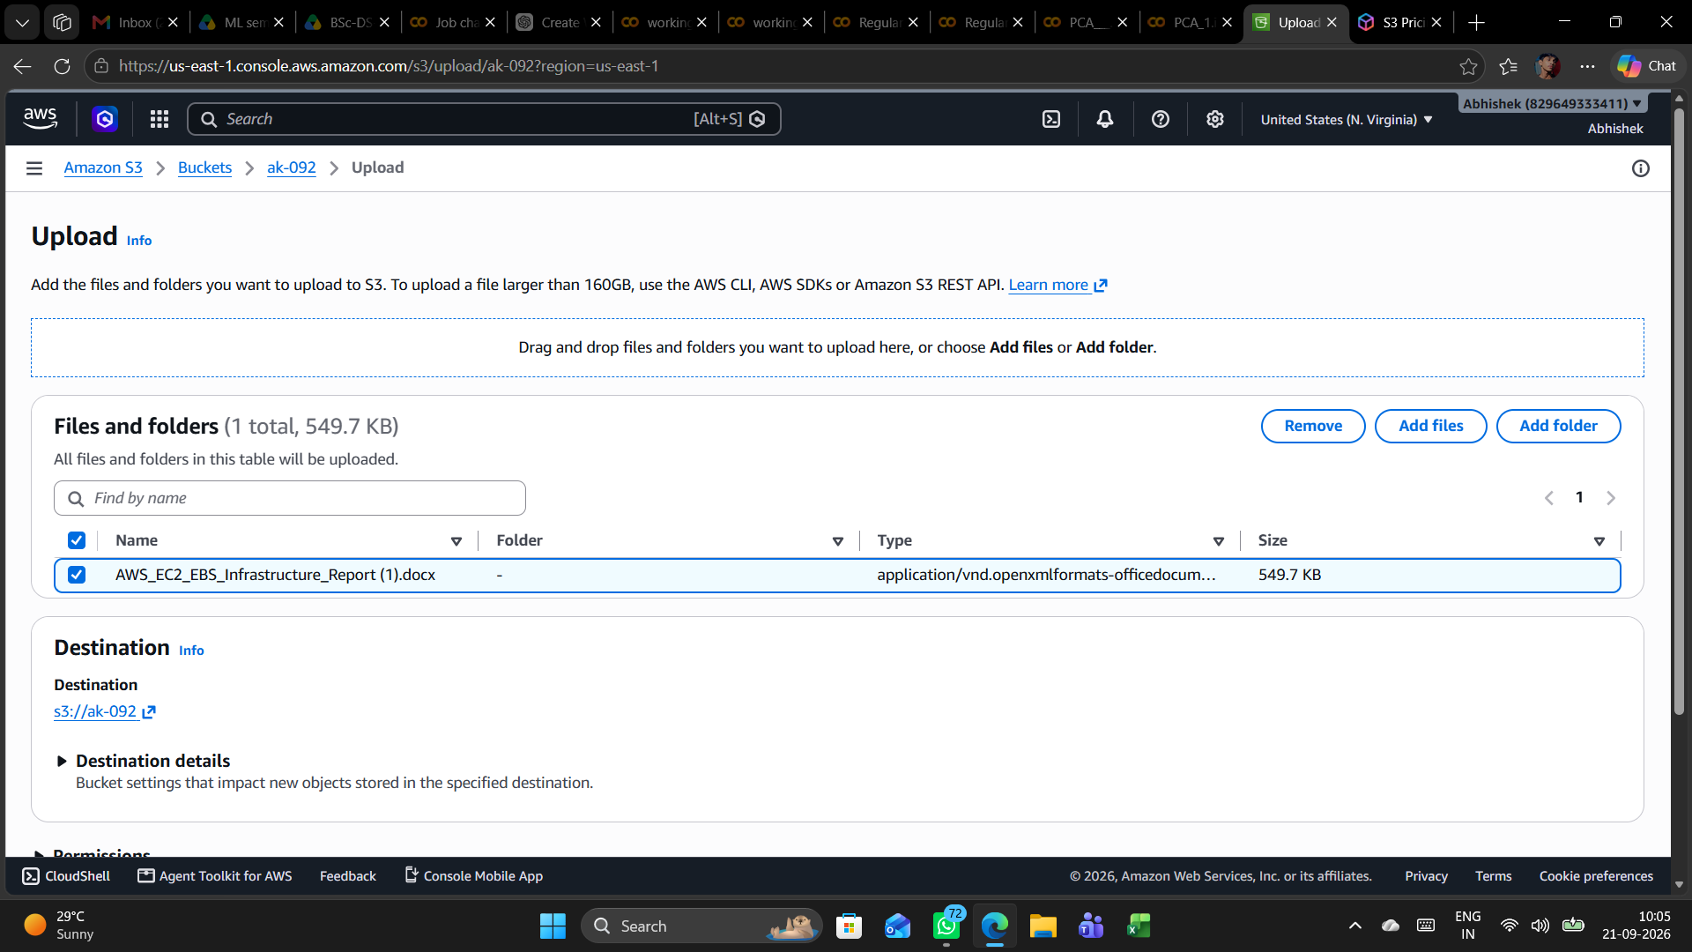

6.12 Upload completed
The S3 upload status reports 1 file succeeded (549.7 KB, 100%) and 0 files failed.
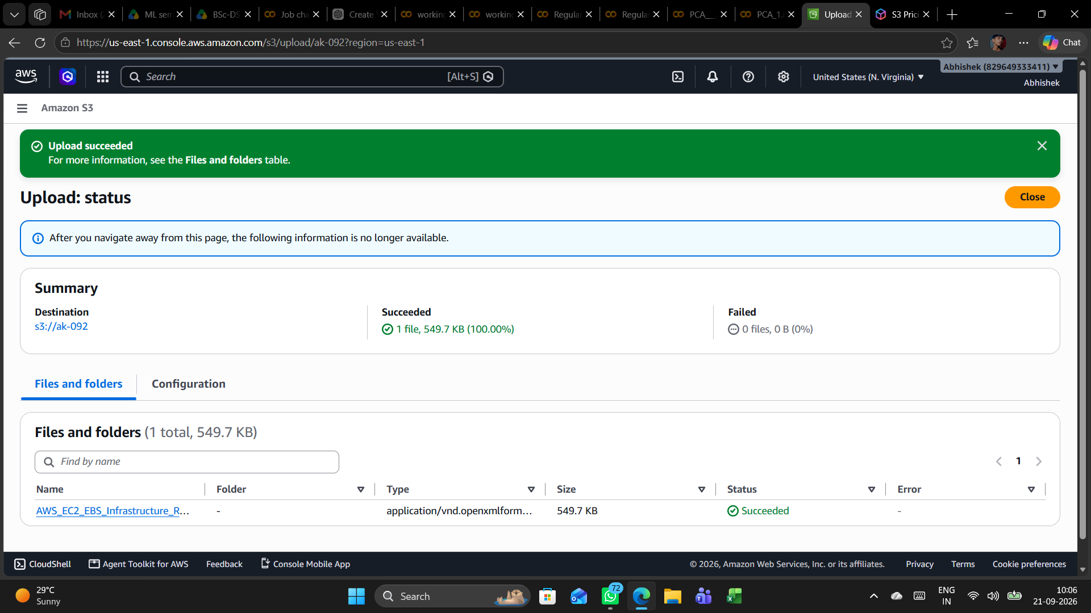

6.13 Uploaded object properties
The uploaded DOCX object is opened in S3. The properties view shows the object key, S3 URI, ARN, region, last-modified timestamp, size, type, ETag, and object URL.
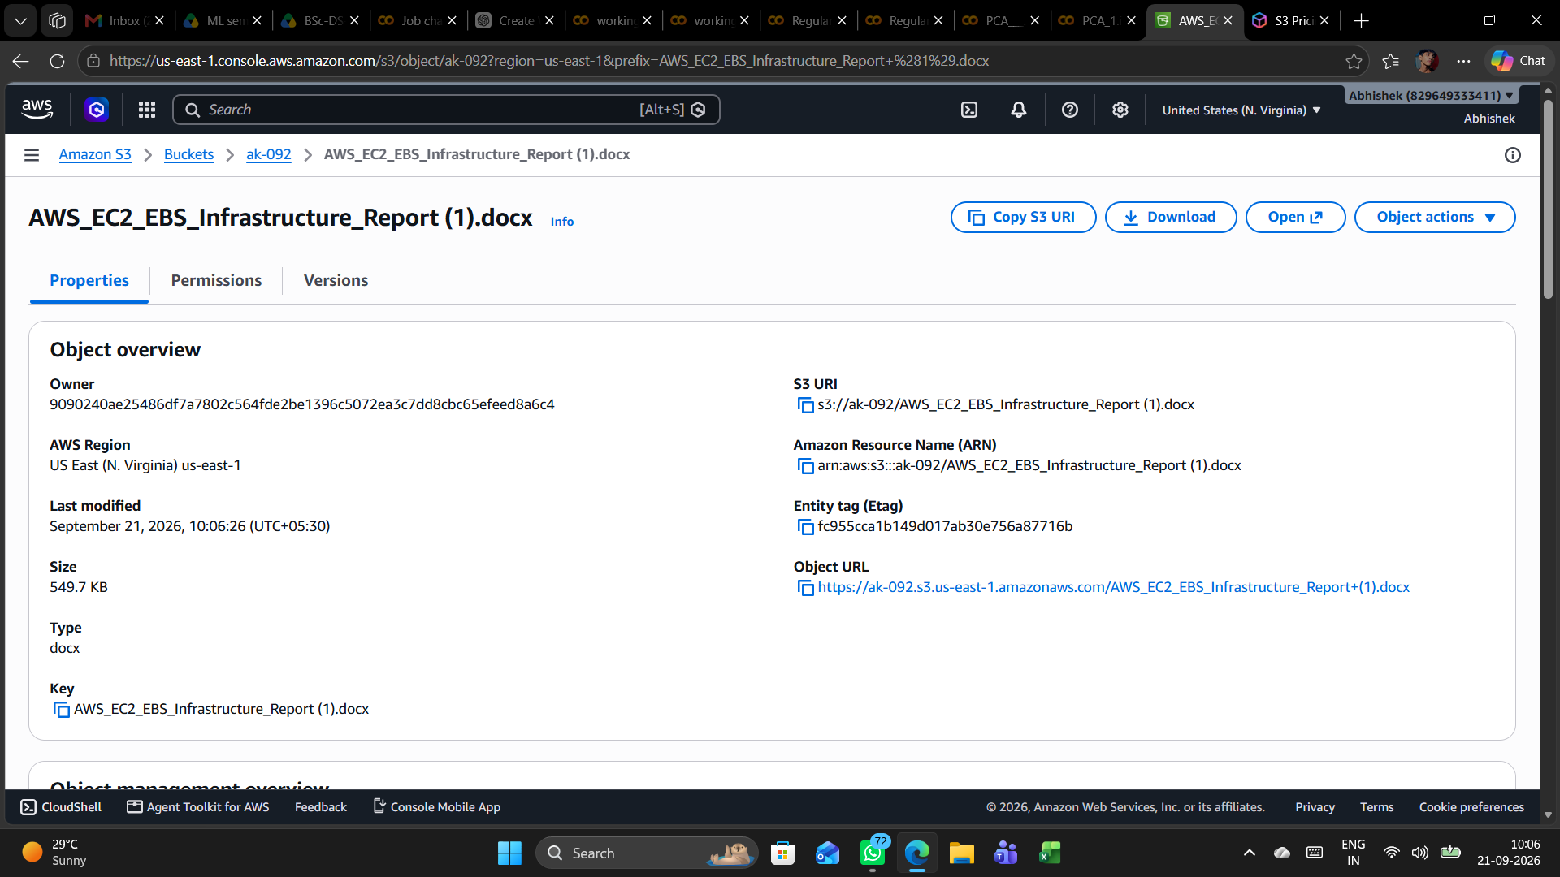

7. Conclusion
The supplied screenshots demonstrate a successful Amazon S3 implementation in which the “ak-092” bucket was created in us-east-1, configured with public-access blocking and SSE-S3 encryption, and used to store an AWS EC2/EBS infrastructure report. The final S3 object view confirms that the document was successfully stored and exposes its associated metadata for verification.

